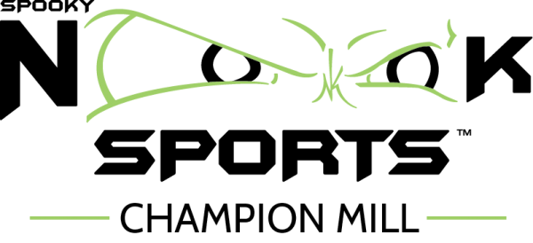 CLASS DESCRIPTIONS
Nook Fit is designed by a personal trainer. This coach lead workout, supportive atmosphere and progressive programming will help you reach your goals. Think Full Body! Prepare your body with a dynamic warm up. Strengthen your muscles through squatting, reaching, pulling, and lifting. This well rounded class will keep you strong with balance, power, mobility and breath work. All Levels Welcome
Cycle is for Serious cyclists, Fitness Gurus or those who just love the calorie burn of Spinning. This is the class for you! It’s a class full of hills, sprints, switch backs and just plain sweat gives you a great cardio and strength workout! All Levels Welcome
Boot Camp uses interval training combining strength training, body weight exercises and cardio. You will challenge your body with a variety of exercises resulting in stronger muscles, increased calories burned and improved body composition. All Levels Welcome
HIIT stands for High Intensity Interval Training. This class is designed to give you the ultimate calorie burn. Short rounds of high impact exercises combined with strength based exercises challenges your cardiovascular and muscular systems. Recommended for Intermediate/Advanced
Zumba®️ is a fitness program that involves cardio and Latin-inspired dance. This dance class features high- and low-intensity intervals that help improve cardiovascular fitness while also enhancing balance, coordination, agility, and to some degree, strength through the application of beginner-accessible choreography. Zumba®️ targets lots of different muscle groups at once for total body toning. All Levels Welcome
Row & Strength is a balanced class that uses Rowing to engage the core, upper body, and lower body. Combining multiple circuits throughout the class keeps your muscles guessing and challenged. All Levels Welcome
Strong Nation®️ is a full body workout that incorporates muscle conditioning, cardio, HIIT, plyometric training and martial arts elements. Every lunge, every squat, every push-up, every move is perfectly synced to music making the workout more efficient. All Levels Welcome
Yoga Stretch & Strength Build full body confidence with energetic Ashtanga flow. Approachable yet challenging, a perfect supplement for all seeking balance. Recommended for Intermediate/Advanced
Energizing Yoga energetic series of poses that challenge strength and stability while improving flexibility and endurance. Targets a variety of muscle groups by incorporating purposeful standing and balancing postures, along with a strong emphasis on core throughout. Intermediate, Advanced
Yoga Move & Breath Class will begin with centering and pranayama and progress to a gentle warm-up, asanas, finishing postures, meditation, and savasana. Leaving you with a sense of well-being and love of self All Levels Welcome
Pilates a strengthening and lengthening form of exercise that focuses on your core, while helping to improve posture and flexibility. All Levels Welcome
Turn Up Dance Fitness dance fitness format that uses hip hop movements and popular music to guide participants through a full body workout. All Levels
Tread & Train HIIT based workout incorporates varying speeds and elevations of the treadmill with strength based exercises to create the ultimate calorie burn. Perfect for a finisher workout or Heart Rate Zone Training All Levels Welcome
Step Aerobics Classic cardio workout. Using a step platform with different patterns of footwork raises the heart rate while strengthening your muscles.
All Levels Welcom

